Murder Project
- Chain of Communication
- Map
- Crime Scene Sketch
- Timeline (if possible)
- Background on Deceased (Information learned)
- Witness Statement
- Medical Reports
Autopsy: list of all injuries

Chain of Communication |  | CSI Team: |  | State:
Case # Requested | Description of Case | Date Requested | Requested from which State | Collected By:

Crime SceneSketch:

- Use this link https://www.smartdraw.com/crime-scene/examples/
- You can also draw the sketch using graph paper and upload into your report

Map

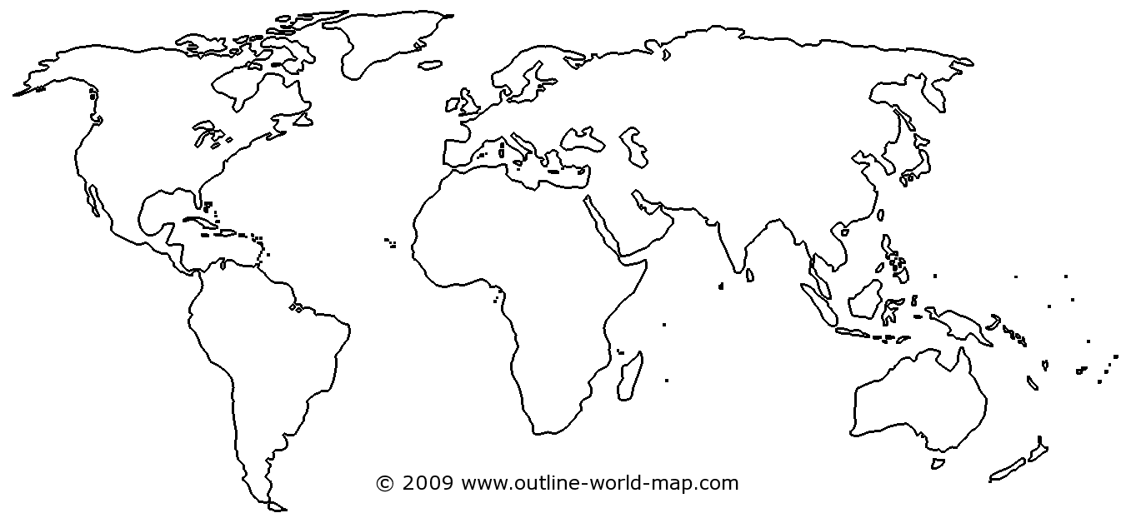
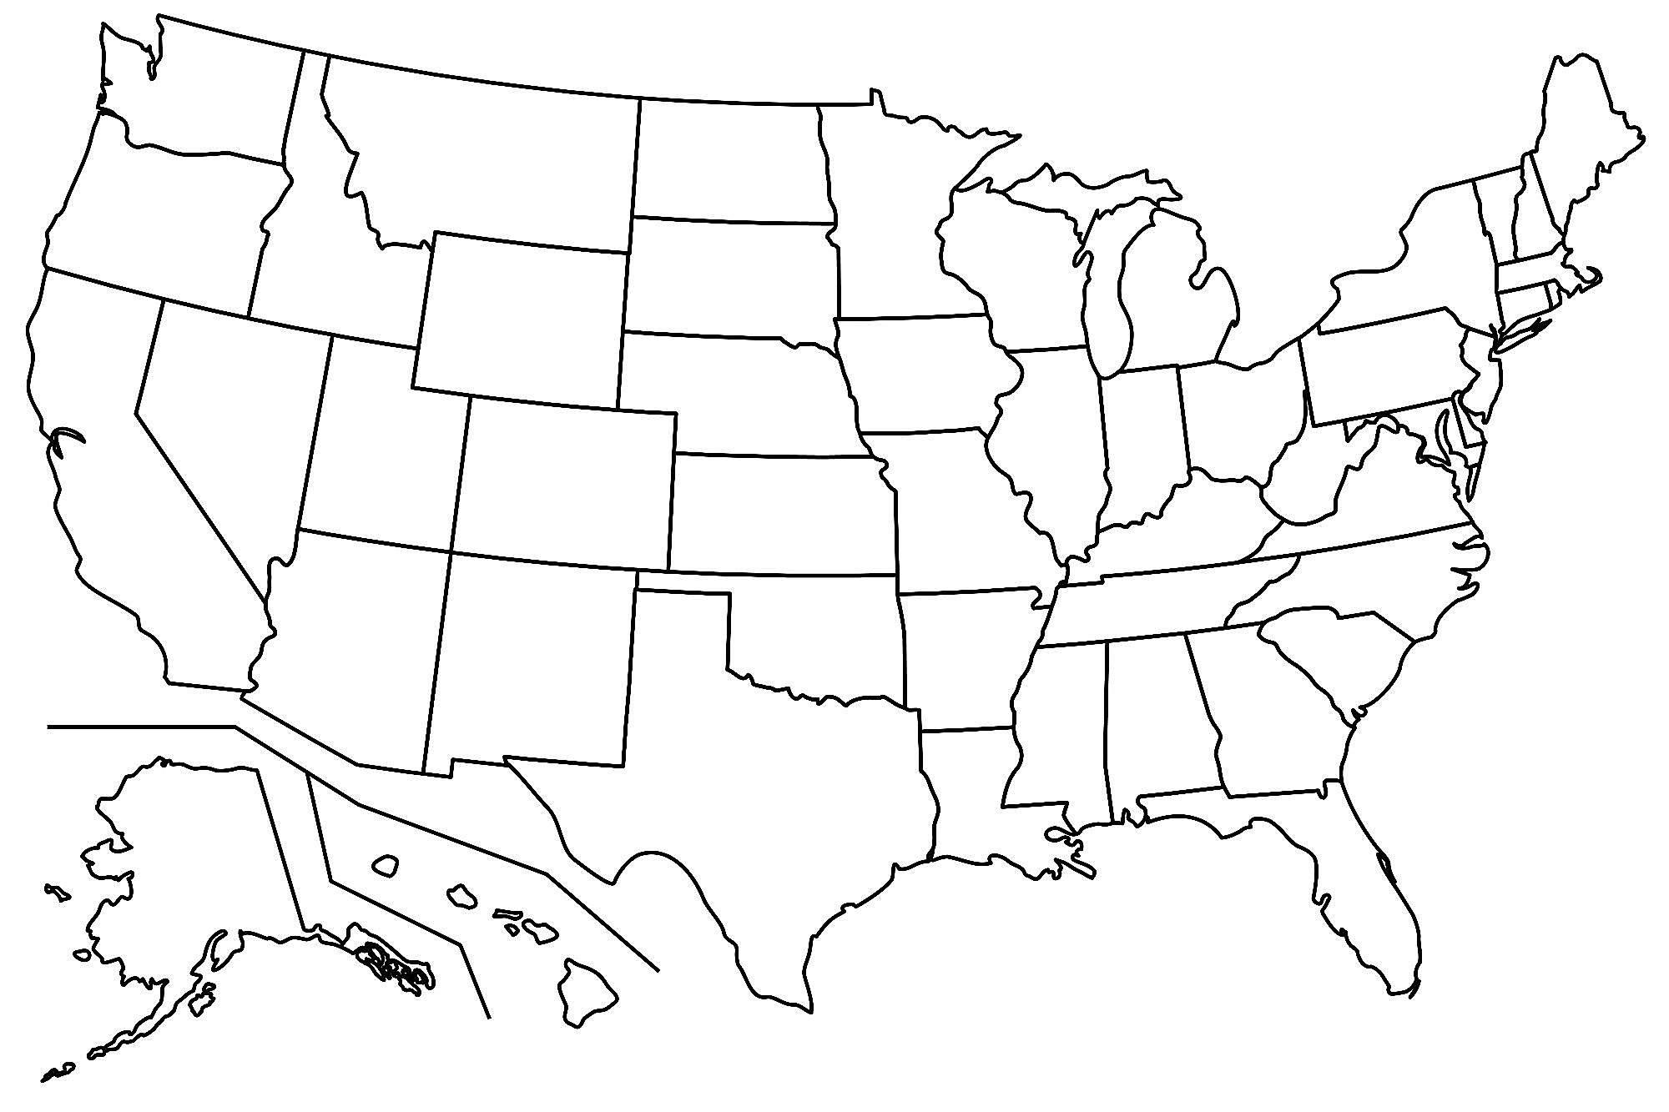

Background of Deceased

Name
Location
Age
Last Known Location
Other

Witness Statements

Medical Reports
(paragraph about key wounds and cause of death)

Main Suspects
(Who is your main suspect and evidence to support it)

